**The turkey pardon is America’s dumbest tradition**

It's time once again for an absurd Thanksgiving ritual.

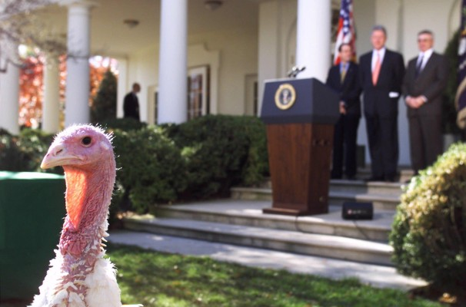A 45-pounder struts in the Rose Garden during a pardoning ceremony by President Bill Clinton, with National Turkey Federation officials Frank Gessell, left, and Jerry Jerome in 1998. (Doug Mills/AP)

On Wednesday, the National Turkey Foundation will carry two plump（饱满的，胖乎乎的） male turkeys over to the White House and lift them onto a table. President Obama will give them goofy（傻瓜的愚笨的） names like [Caramel and Popcorn](http://www.whitehouse.gov/turkey). Then Obama will "pardon" the turkeys and, instead of lopping（砍伐，剪下树枝） off their heads and tossing them in an oven, he will let them live out the rest of their lives at the estate in Mount Vernon.

To be fair, the president has to do lots of frivolous（无聊的，轻佻的，琐碎的） public events like this one every year. But the turkey pardon stands out as being especially dumb and worth abolishing. Here's why:

**-- It's not even a real tradition!** The National Turkey Federation has donated two turkeys to the White House every year since 1947. Harry Truman and Dwight D. Eisenhower did the sensible thing and simply ate the birds. No pardons there.

Some accounts credit John F. Kennedy with the first official turkey pardon, but like most JFK mythologizing（写神话，把……当做神话）, this is overblown sentimentality（多愁善感）: Kennedy merely sent one of his turkeys [back to the farm](http://abcnews.go.com/blogs/politics/2013/11/obama-pardons-turkeys-then-they-die/?utm_source=twitterfeed&utm_medium=twitter) because it wasn't big enough. "We'll let this one grow," he groused（埋怨） of the inadequate offering. (Others credit Abraham Lincoln, [who once spared](http://www.washingtonpost.com/wp-dyn/content/article/2007/11/20/AR2007112002331_pf.html) a turkey destined（指定的，预定的） for Christmas dinner when his son Tad pleaded（辩护） for mercy, but that clearly didn't catch on for decades.)

Ronald Reagan was technically the first president to "pardon" a Thanksgiving turkey, in 1987 — but he did it as a joke to distract the press from scandal. Reporters [had been hounding](http://www.snopes.com/holidays/thanksgiving/pardon.asp)（猎犬，卑鄙的人） the president about whether he planned to grant pardons to key Iran-Contra figures like Oliver North and John Poindexter. Reagan merely quipped that he would have pardoned that year's turkey had it not been en route to a petting zoo already.

Two years later, in 1989, Reagan's successor George H.W. Bush made the turkey pardon an annual ritual（仪式，习惯，例行公事）. But it all started as a glib（口齿伶俐的，油嘴滑舌的） one-liner meant to deflect attention away from White House lawbreaking. Hardly a sacred convention.

**-- The pardoned turkeys aren't that much better off — because the life of a turkey is misery and pain.**This is going to get gruesome（可怕的，阴森的）, and I'm sorry about that. But modern-day domestic turkeys aren't bred to have a happy life. They're raised to be as large as possible so that they can be slaughtered（屠杀） as soon as possible and produce the greatest volume of delicious turkey meat.

Some fun facts: Turkeys bred for eating now grow to an average of 30 pounds — much bigger than wild turkeys.* (The two turkeys on their way to the White House are over 37 pounds apiece.) These domesticated turkeys are often so fat that their skeletons are unable to support that weight. They frequently develop bone deformities（畸形，缺损） and degenerative（疾病恶化的，变性的，退化的） joint diseases. They're incapable of breeding on their own. They often suffer heart failure or bleeding around the kidneys.

So it's no coincidence that, as *[US News & World Report](http://www.usnews.com/news/blogs/washington-whispers/2013/11/19/all-of-president-obamas-pardoned-turkeys-are-dead?s_cid=rss:washington-whispers:all-of-president-obamas-pardoned-turkeys-are-dead&utm_source=twitterfeed&utm_medium=twitter)* and *[National Journal](http://www.nationaljournal.com/white-house/soon-president-obama-will-pardon-a-thanksgiving-turkey-then-it-will-die-20131121)* have discovered, most pardoned turkeys die within a year of being granted a reprieve（赦免） anyway. The White House wants us to believe these turkeys are living out a life of leisure on the farm and bopping along to their favorite Lady Gaga tracks. Not so:

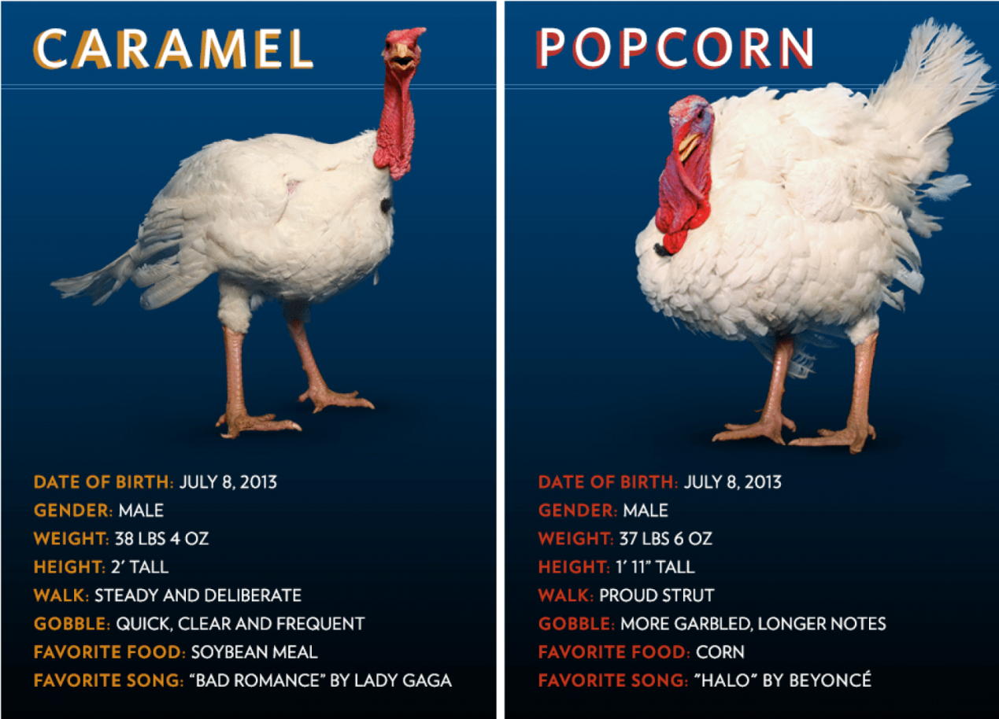

For the record, I'm not opposed to raising turkeys for food (and, yes, it's possible to get humanely raised turkeys). But it's not clear why we need an elaborate White House ceremony designed to obscure where that food actually comes from.

**-- It's a mockery（嘲弄，笑柄，徒劳无功的） of the presidential pardon, which is an all-too neglected issue.**Maybe this isn't surprising, since the turkey pardon was basically invented as a way of mocking（嘲笑，不尊重） presidential pardons. Still, it's worth mentioning.

After tomorrow, Obama will have "pardoned" 10 turkeys in all (turkeys that, as best we can tell, haven't actually committed any crimes). By contrast, he will have only pardoned or commuted the sentences of 40 actual living human beings.

The latter is a record low for modern-day presidents. At the same point in his presidency, Ronald Reagan had pardoned 313 people. Harry Truman had pardoned 1,537 people:

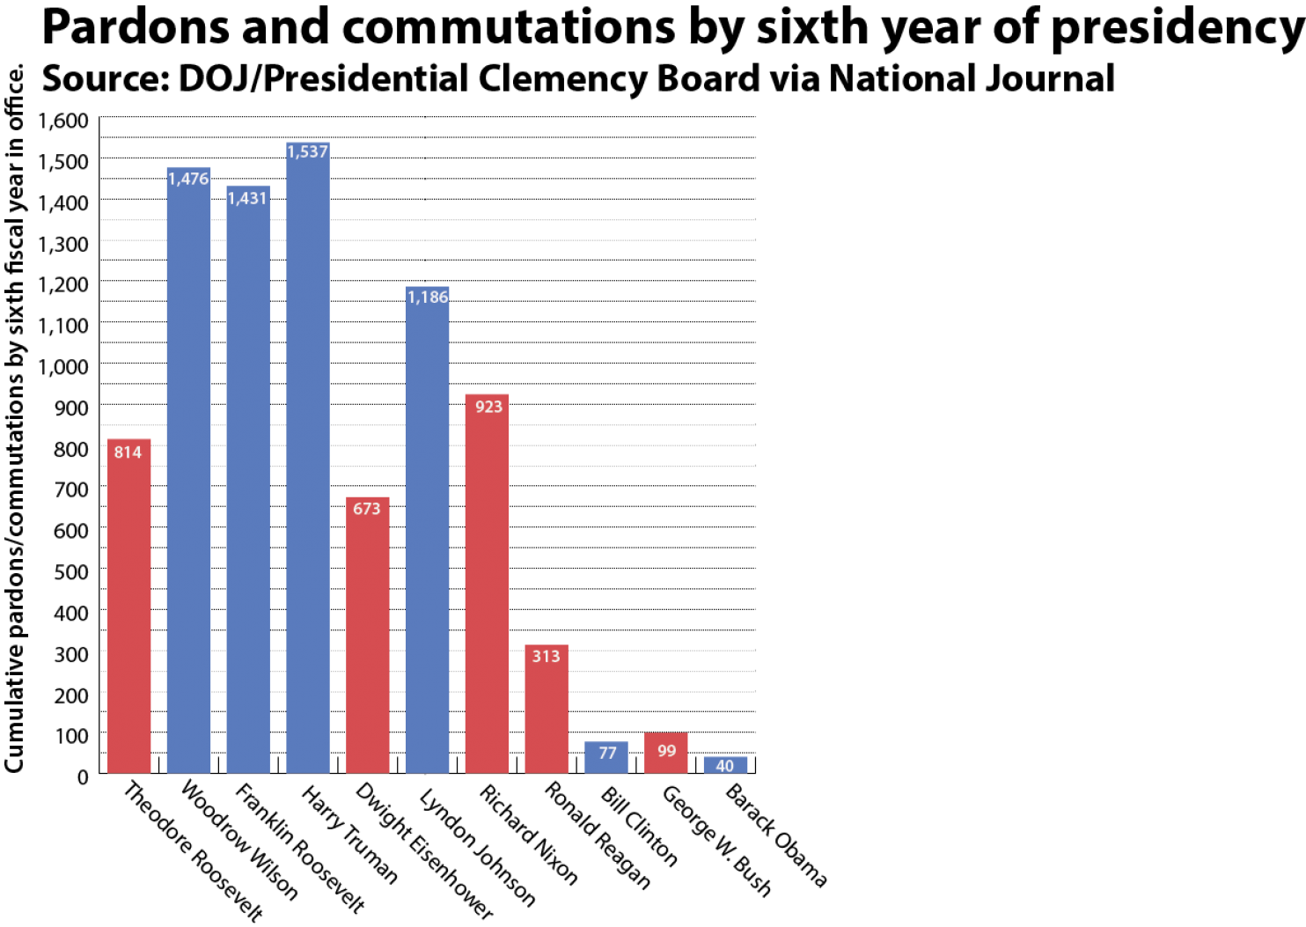

Last year, Sam Morrison, an official who spent 13 years in the Justice Department's Office of the Pardon Attorney before retiring in 2010, [described](http://www.npr.org/blogs/itsallpolitics/2012/11/20/165587441/tough-turkey-people-have-a-harder-time-getting-pardons-under-obama) the prevailing attitude toward pardons this way: "They tend to view any grant of clemency（仁慈，宽厚） not as a good thing, as a criminal justice success story, but almost as a defeat — that you're taking away something from what some good prosecutor （检察官，公诉人）achieved." (The Justice Department disputed this characterization.)

Over at National Journal, Ron Fournier [pointed out](http://www.nationaljournal.com/white-house/will-obama-pardon-this-man-and-many-like-him-or-just-a-turkey-20131125) that, at the bare minimum, Obama could grant clemency to all the people still serving extra time in prison under the old crack-sentencing guidelines — guidelines that Obama himself opposed as excessive and which Congress reduced for all new prisoners in 2010. So far, however, there's no sign that the White House will do this.

The White House does, however, have a flashy Web site up letting you vote on your favorite soon-to-be-pardoned turkey. Yes, there are hashtags.

<https://www.washingtonpost.com/news/wonk/wp/2013/11/26/the-turkey-pardon-is-americas-dumbest-tradition/>

译文：

火鸡赦免仪式是美国最愚蠢的传统

又到了荒谬的感恩节仪式的时候了。

1998年，在比尔·克林顿总统的赦免仪式上，一只45磅重的火鸡在玫瑰园中昂首挺立，美国火鸡联盟官员弗兰克·格塞尔(左)和杰瑞·杰罗姆在一起。(Doug米尔斯/美联社)

周三,土耳其国家基金会将携带两个丰满(饱满的,胖乎乎的)雄火鸡到白宫和提升到一个表。奥巴马总统将给他们高飞(傻瓜的愚笨的)名字像焦糖和爆米花。然后奥巴马将“原谅”火鸡,而不是削减(砍伐,剪下树枝)他们的头,扔在烤箱,他会让他们度过他们的余生在弗农山庄园。

公平地说,总统要做很多无聊的(无聊的,轻佻的、琐碎的)每年这样的公共活动。但是火鸡赦免特别愚蠢，值得废除。原因如下:

——这甚至不是一个真正的传统!自1947年以来，美国国家火鸡联合会每年都向白宫捐赠两只火鸡。杜鲁门(Harry Truman)和艾森豪威尔(Dwight D. Eisenhower)做了件明智的事，干脆把鸟吃了。没有赦免。

一些帐户信贷约翰·f·肯尼迪的首次正式火鸡赦免,但最喜欢肯尼迪神话(写神话,把……当做神话),这是夸大了多愁善感(多愁善感):肯尼迪只派他的一个火鸡回农场,因为它不够大。“我们会让这一发展,”他抱怨道(埋怨)的不足。(其他信贷亚伯拉罕·林肯曾幸免土耳其注定(指定的,预定的)的圣诞晚餐时他的儿子泰德承认(辩护)求饶,但这显然没赶上在几十年了。)

严格来说，罗纳德·里根是第一位在1987年“赦免”感恩节火鸡的总统，但他这么做只是为了让媒体从丑闻中分心。记者一直追捕(猎犬,卑鄙的人)总统关于他是否计划给予赦免关键伊朗门事件数据像奥利弗•诺斯和约翰·波因德克斯特。里根只是打趣说，如果当年的火鸡没有被送到宠物动物园，他就会赦免它。

两年后,在1989年,里根总统的继任者乔治·h·w·布什每年火鸡赦免仪式(仪式,习惯,例行公事)。但这一切开始一个能说会道(口齿伶俐的,油嘴滑舌的)一行程序为了转移注意力从白宫违反法律。这算不上什么神圣的惯例。

——被赦免的火鸡也没有好到哪里去——因为火鸡的生活是悲惨和痛苦的。这是会得到可怕的(可怕的,阴森的),我很抱歉。但是现代饲养的火鸡并不是为了拥有幸福的生活。他们将尽可能大,这样就可以屠杀(屠杀)尽快和生产的最大体积美味的火鸡肉。

一些有趣的事实:为了食用而饲养的火鸡现在平均长到30磅——比野生火鸡大得多。(这两只即将入主白宫的火鸡体重都超过了37磅。)这些家养火鸡通常都太胖了，以至于它们的骨骼无法承受这么重的重量。他们经常开发骨骼畸形(畸形,缺损)和退行性(疾病恶化的,变性的,退化的)关节疾病。它们不能自己繁殖。他们经常患有心力衰竭或肾脏周围出血。

这是巧合,美国新闻与世界报道》和国家杂志发现,多数赦免火鸡死在一年之内被授予缓刑(赦免)。白宫想让我们相信这些火鸡在农场过着休闲的生活，跟着它们最喜欢的Lady Gaga的歌曲蹦蹦跳跳。不:

郑重声明，我并不反对饲养火鸡作为食物(当然，人道地饲养火鸡也是有可能的)。但目前还不清楚为什么我们需要一场精心设计的白宫仪式来掩盖这些食物的真正来源。

——这是一个嘲弄(嘲弄,笑柄,徒劳无功的)总统原谅,这是一个极为被忽视的问题。也许这并不奇怪,因为火鸡赦免基本上是发明的嘲笑(嘲的笑,不尊重)总统赦免。尽管如此，它还是值得一提。

明天之后，奥巴马将总共“赦免”10只火鸡(据我们所知，这些火鸡实际上并没有犯下任何罪行)。相比之下，他只赦免或减刑了40名活生生的人。后者是现代总统的最低纪录。在他担任总统的同一时期，罗纳德·里根赦免了313人。哈里·杜鲁门赦免了1537人

山姆·莫里森(Sam Morrison)曾在司法部特赦检察官办公室(Justice Department Office of the Pardon Attorney)工作13年，2010年退休。去年，他这样描述了人们对赦免的普遍态度:“他们倾向于把任何的宽恕(仁慈,宽厚)不是一件好事,刑事司法的成功故事,但几乎失败,你拿走东西的一些好的检察官(检察官,公诉人)。”(司法部驳斥了这种说法。)

在国家杂志,罗恩·弗尔涅指出,在最低限度,奥巴马可以给予所有的人仁慈还提供额外的时间在监狱的老crack-sentencing指南——指南下奥巴马反对过度和国会减少所有新囚犯在2010年。然而，到目前为止，还没有迹象表明白宫会这么做。

然而，白宫确实有一个华丽的网站，让你投票选出你最喜欢的即将被赦免的火鸡。是的，有标签。